Recovery Model in Action
at Milestones

Milestones is funded by the Mental Health Services Act (MHSA) grant allotted by the State of California. Milestones is a drop-in center for community members who self-identify with a mental health diagnosis. At Milestones, all of the activities are consumer driven and anyone interested is encouraged to participate.

At Milestones –
- Consumers are involved in the planning process.
- Consumers organize and implement the Trinity County Wellness Center Advisory Council (by-laws, officer elections, Roberts Rules of Order implemented). The Council is made up of consumers from both Trinity County Wellness Centers.
What Does MHSA do?

- The MHSA funds new mental health services by means of a 1% tax on earned income over $1 million, starting with the second million.
- MHSA programs serve people of all ages, including children, youth and families, transition-age youth, adults, and older adults.
- The Act mandates that all programs funded through these new revenues be:
- Client centered and family focused.
- Based on wellness & recovery principles.
- Culturally and linguistically competent.
- Provide an integrated service system.

- Activities and classes are offered by and for consumers.
- Leadership Group / Peer Training classes are provided by Peer Specialists to educate and support consumers interested in future employment.
- Wellness & Recovery Action Plan (W.R.A.P.) class (8-weeks), followed by a W.R.A.P support group, are offered by certified WRAP facilitators to help prepare and support consumers in taking action in their personal recovery.
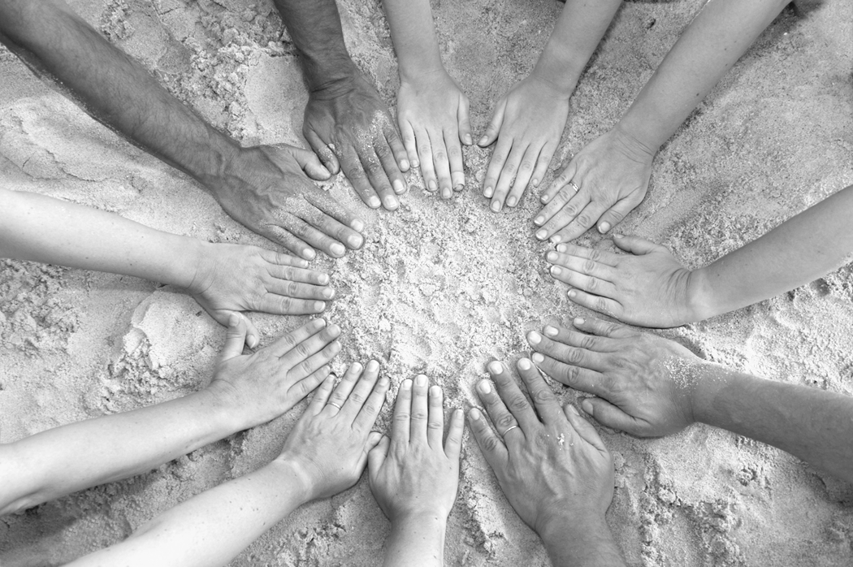
- Continuing Education is frequently offered to consumers promoting wellness and recovery.
What is the Mental Health Services Act (MHSA)?
Vision & Mission Statements
for Milestones:
VISION: Our purpose is to nourish human beings in their effort at wholeness and to achieve the goal of recovery: spiritually, emotionally, physically, and intellectually.
MISSION:
- To provide support and acceptance, enhance belonging, social inclusion, and quality of life in a clean, sober, and safe environment.
- We focus on helping people gain satisfaction within their own life by incorporating life skills, getting involved in the local community, work readiness, increasing self-esteem, reducing stigma, and honoring each person’s individual recovery.
- We are encouraged to value the “pay it forward” philosophy of receiving help and, in time, helping others in succeeding at self-directed goals and independent living.
- We model and promote individuals being happy not just for others but truly within themselves.

–- This statement was put together by the Peer Specialist members of the Milestones Wellness Center.

In November 2004, California voters approved Prop 63 (an initiative that was developed in partnership with family members, service providers, community advocates, and consumers) and the Mental Health Services Act became law.

“Nothing About Us
Without Us”
- Recovery Model Moto

