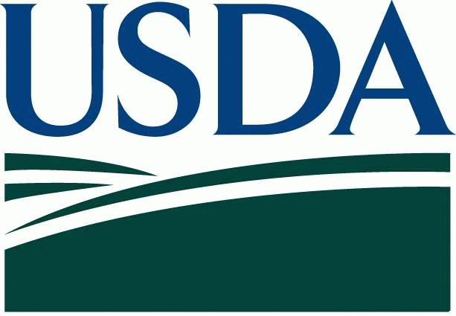
United States Department of Agriculture FACT SHEET
August 2020
Fire Recovery Assistance from the U.S. Department of Agriculture

The U.S. Department of Agriculture (USDA) has multiple agencies that provide financial and/or technical assistance to help farmers, ranchers and rural landowners recover from natural disasters, such as wildfires. Listed below are USDA agencies and an overview of applicable programs. Funding for some programs are contingent on the on the annual enactment of Congressional appropriations legislation.

Farm Service Agency (FSA)

- Livestock Indemnity Program (LIP): Compensates producers for livestock death due to natural disasters. Compensation is based on roughly 75percent of the national average price of the livestock by type and age. Report losses within 30 days. Complete applications are due 60 days after the end of the calendar year.

- Emergency Livestock Assistance Program (ELAP): Compensates producers for a percentage of the pasture or forage loss on private lands due to natural disasters. Payments are subject to a national payment factor. Report losses within 30 days. Complete applications are due 30 days after the end of the calendar year.

- Livestock Forage Disaster Program (LFP): Compensates producers who suffer pasture or forage loss due to drought or who have federally managed grazing leases but are not allowed to graze the lease because of wildfire. Report losses within 30 days. Complete applications are due 30 days after the end of the calendar year.

- Emergency Loans – low interest loans to replace farm and ranch buildings and structures, make repairs or replace livestock or feed. Must meet disaster/emergency criteria.
- Emergency Haying and Grazing of Conservation Reserve Program (CRP): approval will be based on drought severity as determined by the U.S. Drought Monitor. Producers located in a county that is designated as severe drought (D2) or greater on or after the last day of the primary nesting season may be eligible. A list by state and map of eligible counties are updated weekly. Check with your local FSA county office for more information.
- Emergency Conservation Program (ECP): is administered by the U.S. Department of Agriculture (USDA) Farm Service Agency (FSA), provides emergency funding and technical assistance to farmers and ranchers to rehabilitate farmland and conservation structures damaged by natural disasters and implement emergency water conservation measures in periods of severe drought.
- Emergency Forest Restoration Program (EFRP): Provides payments to nonindustrial private forest land owners for emergency measures to restore land damaged by a natural disaster. This program is contingent on funding available.
- Tree Assistance Program (TAP): Provides financial assistance to replant or rehabilitate eligible trees, bushes and vines damaged by natural disasters. Forests are not eligible.

- Non-Insured Crop Disaster Assistance Program (NAP): Provides compensation to producers who grow uninsurable crops and have purchased NAP coverage by the crop signup dates.

- For more information, visit http://disaster.fsa.usda.gov
- To find your local FSA county office, visit http://offices.usda.gov

Risk Management Agency (RMA)

Provides insurance to farmers and ranchers who have previously enrolled in the subsidized multi-peril crop and livestock insurance programs.
rsoca@usda.gov
Davis RO: https://www.rma.usda.gov/RMALocal/California
RMA Website: www.rma.usda.gov

Natural Resources Conservation Service (NRCS)

- The Environmental Quality Incentives Program (EQIP) may be able to pay on grazing lands if producers agree to defer grazing on damaged land for 2 years. An application period will be announced in the near future.

- The NRCS Emergency Watershed Protection (EWP) Program may be able to provide financial assistance where a fire has created a situation were excessive soil erosion could occur from a rain event creating a threat to life and improved property.

- General Requirements:
- Eminent threat to life and property.
- Local sponsor is willing and able to represent the local community.
- Must be demonstrated that all local financial resources have been utilized.

California Cooperative Research and Extension
- In addition to the USDA resources listed above, expertise and assistance on subjects (e.g. Re-seeding, Erosion & Flooding, Livestock, Salvage Logging and Reforestation) may be available through local or regional Extension offices.

USDA Agency Contacts:

Farm Service Agency - State Office
430 G St. Ste 4161
Davis, CA 95616
530-792-5520
Or check this link for your county office
http://offices.usda.gov.
Natural Resources Conservation Service State Office
430 G St. Ste 4164
Davis, CA 95616
(530) 792-5600
Or check this link for your local county office

Risk Management Agency Regional Office
430 G St. Ste 4168
Davis, CA 95616
530-792-5870

