MOBILE FOOD FACILITY (MFF) FREQUENTLY ASKED QUESTIONS

What exactly is a Mobile Food Facility? A mobile food facility (MFF) is defined as “any vehicle used in conjunction with a commissary or other permanent food facility upon which food is sold or distributed at retail.” This includes full-service catering trucks, taco trucks, hot dog carts, ice cream trucks, and coffee carts. For more detailed information, please see our handout for Classification and Permitting Requirements.

Can I operate my MFF wherever I want? All MFF’s (including carts) shall obtain approval from the local Planning and Zoning departments to operate on either private and public property, and also the property owner for private property.

Do I have to put anything besides the name of my business on the side of my MFF? All MFF’s shall have the business name or name of the operator (3” high lettering) and the city, state, and zip code (1” high lettering) permanently affixed on two sides of the vehicle.

What is CA Housing & Community Development (HCD), and why do I need their approval?
CA Housing & Community Development is a state agency that inspects and certifies vehicles as “special purpose commercial modular.” California Health & Safety Code section 18012.5 defines a special purpose commercial modular as“…a vehicle with or without motive power, designed and equipped for human occupancy for industrial, professional or commercial purposes…” This includes any fully enclosed MFF in which the operator occupies the vehicle to cook or prepare food for service. No Environmental Health Permit to operate will be issued to any fully enclosed MFF that does not contain an HCD Insignia from having passed HCD inspection.

What does the HCD insignia look like? Here is a sample HCD special purpose commercial modular insignia.

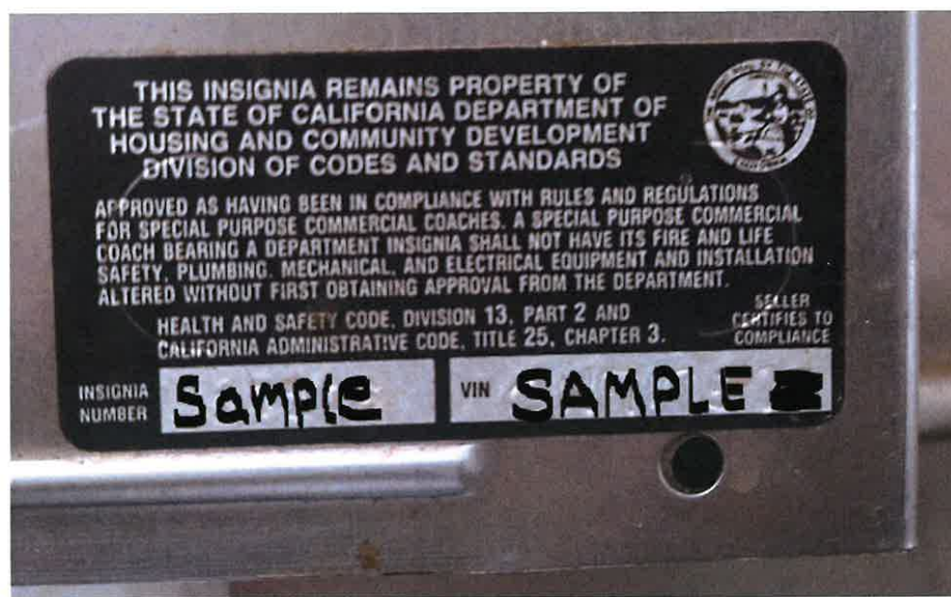

I bought my Food Truck used and I can’t find an HCD Insignia on it. How can I find out if it has passed inspection in the past? Contact Manufactured Housing at 916-445-3338. For a small fee they will research to see if the mobile vehicle has ever been issued the insignia. If it has, they will provide you with a duplicate insignia.

My vehicle has never been issued the HCD insignia, who do I contact to schedule an inspection? Contact the HCD Northern California Field Office @ 916-255-2501. They will have you submit the following items to schedule your inspection:
• Form 415 (www.hcd.ca.gov/codes/mhp/HCD415_Rev07-13.pdf)
• A copy of current vehicle registration
• A required fee Once your vehicle contains the HCD insignia, you are ready to complete the permitting process with Placer County Environmental Health.

What is a commissary and why do I need one? A commissary is an approved, permitted commercial kitchen which an MFF shall use for storage of food and supplies, cleaning and sanitizing of utensils, sanitary disposal of garbage and liquid waste, filling of the potable water tank, cleaning and maintenance of the MFF, and any food prep that can’t be performed inside the vehicle. An MFF operator is NOT PERMITTED to do any of these activities at home.

What is considered limited food preparation? See below, an excerpt from the definition of limited food preparation, per California Retail Food Code section 113818:
(a) Limited food preparation means food preparation that is restricted to one or more of the following:
(1) Heating, frying, baking, roasting, popping, shaving of ice, blending, steaming or boiling of hot dogs, or assembly of non-prepackaged food.
(2) Dispensing and portioning of non-potentially hazardous food.
(3) Slicing and chopping of food on a heated cooking surface during the cooking process.
(4) Cooking and seasoning to order.
(5) Preparing beverages that are for immediate service, in response to an individual consumer order, to do not contain frozen milk products.
(b) Limited food preparation does NOT include any of the following:
(1) Slicing and chopping unless it is on the heated cooking surface.
(2) Thawing.
(3) Cooling of cooked, potentially hazardous food.
(4) Grinding raw ingredients or potentially hazardous food.
(5) Reheating of potentially hazardous foods for hot holding, except for steamed or boiled hot dogs and tamales in the original, inedible wrapper.
(6) Hot holding of non-prepackaged, potentially hazardous food, except for roasting corn on the cob, steamed or boiled hot dogs, and tamales in the original inedible wrapper.
(7) Washing of foods.
(8) Cooking of potentially hazardous foods for later use.

I want to open a hot dog cart and serve brats and other specialty sausages. Can I do this?
To prepare and serve sausages from a cart (or other unenclosed vehicle) without the requirement of a 3- compartment sink, the sausages are required to meet the definition of a hot dog per CalCode section 113807: “Hot dog means a whole, cured, cooked sausage that is skinless or stuffed in a casing…” Preparation of any sausage that does not meet the definition of a hot dog is considered full prep and will require a fully enclosed mobile facility.

Am I allowed to use my custom-built BBQ in conjunction with my MFF?
A MFF may only utilize an open-air BBQ or outdoor wood-burning oven at a permitted Community Event. Please speak with the event coordinator or contact Trinity County Environmental Health to determine if it is a permitted Community Event.

Am I allowed to set up a pop-up tent or a table to make fresh squeezed lemonade? A MFF may only set up pop-up tents and tables outside the vehicle at a permitted Community Event. Please speak with the event coordinator or contact Trinity County Environmental Health to determine if it is a permitted Community Event.

I’ve been asked to come to the local brewery/winery on Friday evenings. Is this considered a Community Event? Community events must be temporary in nature to meet Trinity County Environmental Health’s requirements for permitting. A local brewery/winery that serves beverages to the public on a daily or weekly basis, year-round, cannot be permitted as a Community Event. As a permitted MFF, you may operate at the brewery/winery, however, YOU MAY NOT set up pop-up tents or utilize an open-air BBQ or outdoor wood burning oven, as those are only allowed at Community events.

Do I have to fill out the Restroom Verification Form? The restroom verification form (Section F of the application packet) shall be filled out if your MFF conducts business in a specified location for more than one hour. The owner of the restroom must sign the form stating they are granting permission for your facility to use the restroom, and that they will maintain the cleanliness and the supplies inside the restroom.

Is a food vendor considered a food facility? Yes. See section 114381.2 of the California Retail Food Code. A permit application shall be submitted to the enforcement agency by each temporary food facility operator that includes all of the following:
1. A booth plan that indicates the proposed layout of equipment, food preparation tables, food storage, ware washing, and hand washing facilities.
2. Details of the materials and methods used to construct the temporary food facility, including required netting/screens/walls.
3. All food products that will be handled and dispensed.
4. The proposed procedures and methods of food preparation and handling.
5. Procedures, methods, and schedules for cleaning utensils, equipment, and structures, and for the disposal of refuse.
6. How food will be transported to and from a permanent food facility or other approved food facility to the temporary food facility, including steps taken to prevent contamination of foods.
7. How potentially hazardous foods will be maintained at or below 41°F or at or above 135°F.

My food is prepackaged...do I still need a permit? Yes. A permit is still required. However, certain requirements may not apply if the food is not potentially hazardous (such as; candy, canned soda, bottled water) I am only selling or giving away drinks ... do I still need a permit? Yes. Beverages are considered food, and a permit is required. The requirements for bottled or canned beverages are the same as for prepackaged food. There are special considerations for nonprofit and winery operations.

Can I prepare food at my home for sale/distribution from a temporary food facility? No. Food intended for public consumption may not be prepared in a home. All food must be obtained from approved sources. Exception: 114339. Non-potentially hazardous beverages and baked goods may be offered for sale, sold, or given away by a nonprofit charitable organization or by an established club or organization that operates under the authorization of a school or educational facility for fundraising purposes at community events. Note: A valid Cottage Food Operation is considered a food facility and may sell food as a vendor.

Do I need a permit if I’m a non-profit organization? Yes. A permit is required for all food vendors offering food for sale to the public. The potential risk associated with handling food is the same, regardless of where the proceeds go.

Do I need a permit to have a private party? No. Private parties intended only for members of an organization and/or their invited guests do not require a permit. If the event is advertised to the public; however, then a permit is required.

Do church potlucks or private club dinners need a permit? No. A church, private club, or other nonprofit association that gives or sells food to its members and guests, and not to the general public, at an event that occurs not more than three days in any 90-day period.

How long is the permit valid? The permit issued to a temporary food facility vendor may be valid for up to one year, or the vendor may choose to get a permit for only a single event. The permit issued to the event organizer is valid only for the duration of that specific community event. A new application must be submitted, and a new permit obtained for each community event.

I already have a permit for my restaurant in Trinity County. Does that permit me to participate in temporary / special events? Yes. The permit for your restaurant is site-specific but does transfer to any other temporary food facility location for a special event. However, you still must apply for a Temporary Food Facility permit, there is one specifically for Permanent Food Facilities that have an existing annual PTO and have already paid the annual fee.

Are other fee reductions available? Yes. Honorably Discharged Veterans with a DD-214 and nonprofit organizations with 501(c) 3 documentation must apply for a Temporary Food Facility permit specific to being a veteran or nonprofit.

When do I need to submit my application? At least 2 weeks prior to the event to allow adequate time to review the application, vendor list, and make any necessary adjustments and modifications.

